Morocco

## Political Stability Estimate Data

The data set shows the political stability estimate of the country each year.

## # A tibble: 19 x 5  
## country iso3c date stability stabilityCategory4   
## <chr> <chr> <dbl> <dbl> <chr>   
## 1 Morocco MAR 1996 -0.207 moderately unstable  
## 2 Morocco MAR 1998 0.309 moderately stable   
## 3 Morocco MAR 2000 -0.0656 moderately unstable  
## 4 Morocco MAR 2002 -0.264 moderately unstable  
## 5 Morocco MAR 2003 -0.405 moderately unstable  
## 6 Morocco MAR 2004 -0.312 moderately unstable  
## 7 Morocco MAR 2005 -0.556 moderately unstable  
## 8 Morocco MAR 2006 -0.461 moderately unstable  
## 9 Morocco MAR 2007 -0.500 moderately unstable  
## 10 Morocco MAR 2008 -0.571 moderately unstable  
## 11 Morocco MAR 2009 -0.398 moderately unstable  
## 12 Morocco MAR 2010 -0.383 moderately unstable  
## 13 Morocco MAR 2011 -0.392 moderately unstable  
## 14 Morocco MAR 2012 -0.470 moderately unstable  
## 15 Morocco MAR 2013 -0.493 moderately unstable  
## 16 Morocco MAR 2014 -0.446 moderately unstable  
## 17 Morocco MAR 2015 -0.341 moderately unstable  
## 18 Morocco MAR 2016 -0.313 moderately unstable  
## 19 Morocco MAR 2017 -0.410 moderately unstable

## Political Stability Estimate Plot

The plot shows the trends of stabilization and destabilization for the each country.

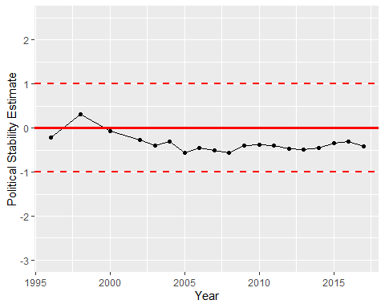

Political Stability Trend